Test Scenario 2

Description

Check Email Notiﬁcation:
*Open All menus → Search Emails.

*Under System logs → Select Emails.

*Search with the Given Subject Name.

*Open that Record and Under Related Links Click Preview
mail Option.

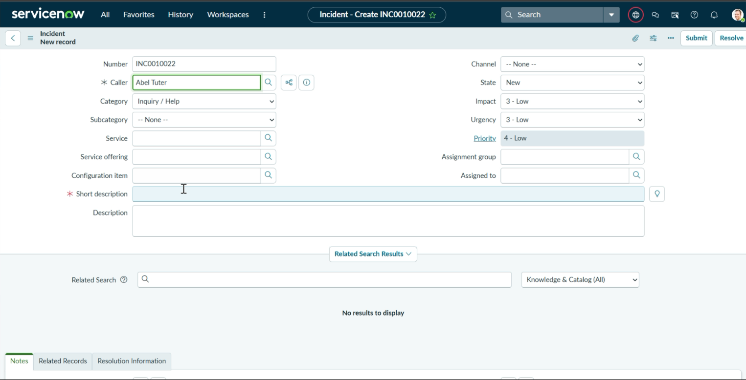
- Enter one Caller Name.
- Short Description: Projector not turning on.
- Then Save the Form.
- And Reload the Form.

- Then it fills auto as :
- Category → Hardware.
- Subcategory → Projector.
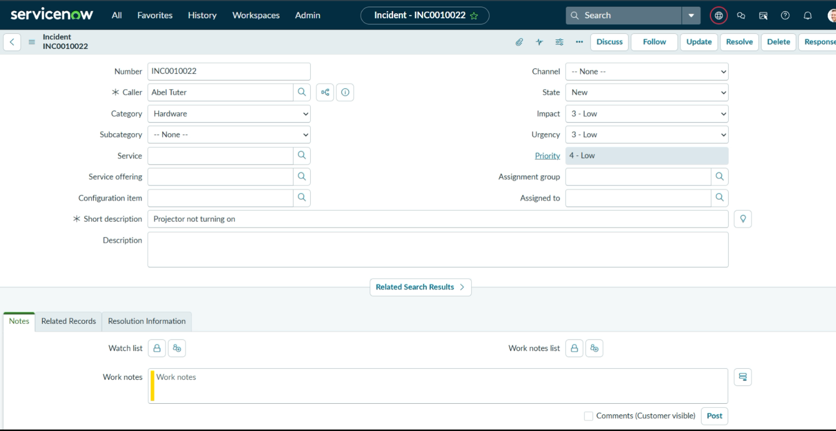
- Then Email sent to caller Mail id.

